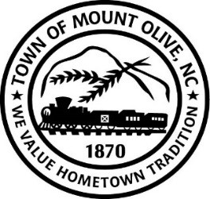
REGULAR BOARD MEETING AGENDA
TUESDAY MARCH 8, 2022
114 EAST JAMES STREET
7:00 P.M.
I. CALL TO ORDER -
Invocation
Pledge of Allegiance
II. ROLL CALL –
III. READ CONFLICT OF INTEREST STATEMENT -
In accordance with the State Government Ethics Act, it is the duty of every Member of the Mount Olive Board of Commissioners to avoid both conflicts of interest and appearances of conflict.

Does any member of the Board of Commissioners have any known conflict of interest or appearance of conflict with respect to any matters coming before the Board of Commissioners today?

If so, please identify the conflict or appearance of conflict and refrain from any undue participation in the particular matter involved.

IV. APPROVAL OF PUBLISHED AGENDA (*Motion/Second-Roll Call)

V. APPROVAL OF MINUTES (*Motion/Second-Roll Call)
a. February 08, 2022 Meeting.
b. February 18, 2022 Special Called Meeting

VI. PUBLIC FORUM
Speakers must state name, address, phone number and hold comments to maximum of three minutes.

VII. NON-ACTION MEMO (*Motion/Second-Roll Call)

03-18 – Review of Carver Cultural Center Plan of Action

VIII. ACTION MEMO (*Motion/Second-Roll Call)

03-19- Consider Approval of Plan to Affirmatively Further Fair Housing.
03-20- Consider Approval of Updated Resolution Celebrating the 150th Anniversary.
IX. TOWN MANAGER’S REPORT
X. MAYOR AND BOARD OF COMMISSIONERS REPORTS

ADJOURN

