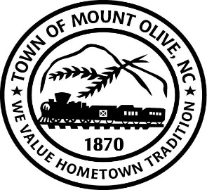
SPECIAL CALLED BOARD MEETING AGENDA
THURSDAY JANUARY 27, 2022
114 EAST JAMES STREET
3:00 P.M.
I. CALL TO ORDER -
Invocation
Pledge of Allegiance
II. ROLL CALL –
III. READ CONFLICT OF INTEREST STATEMENT -
In accordance with the State Government Ethics Act, it is the duty of every
Member of the Mount Olive Board of Commissioners to avoid both conflicts of interest and appearances of conflict.

Does any member of the Board of Commissioners have any known conflict of interest or appearance of conflict with respect to any matters coming before the Board of Commissioners today?

If so, please identify the conflict or appearance of conflict and refrain from
any undue participation in the particular matter involved.

IV. ACTION MEMO (*Motion/Second-Roll Call)

01-06 -Consider Adoption of Waste Water Treatment Plant Headworks Short Term Monitoring Plan as Required by our Special Order of Consent.
ADJOURN

